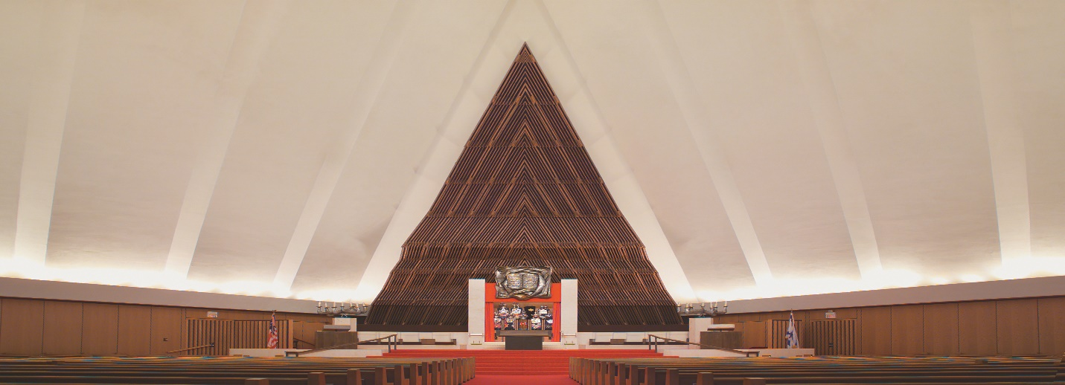
Bar/Bat Mitzvah Timeline
12 Months
Begin lessons with Cantor
6 Months
Begin lessons with Rabbi
Set up appointment with Executive Director
Confirm use of building for reception and evening party
3 Months
Give list of Torah readers to Cantor (optional)
1 ½ Months
Review Honors list with Rabbi
If preparing a program, review with Rabbi
3 Weeks
Turn in completed Honors form
Turn in completed Logistics form
Pay dues, tuition, pledges
1 Week
Pay room rental fees
Bring check for security guard
Inform office of wording for TAY and You

